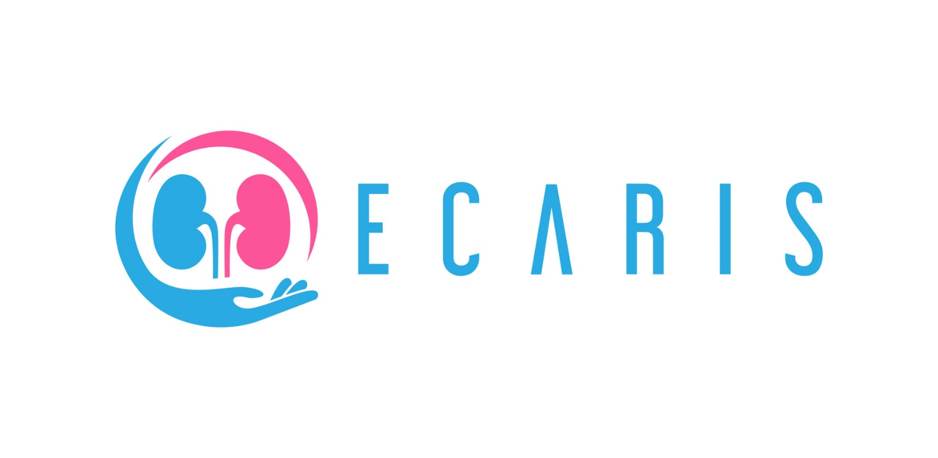
Ecaris eCourse for informal carers of patients with Chronic kidney disease Report

Index

Introduction 3
eCourse overview 3
Pilot testing 6
Participants profile 8
Pilot Results 15
Focus Groups Quotes 18
Conclusions 22
Annex 1 23

The European Commission support for the production of this document does not constitute an endorsement of the contents which reflects the views only of the authors, and the Commission cannot be held responsible for any use which may be made of the information contained therein

Introduction
Output 3 objective is to pilot the blended learning programme build during IO2 in order to gather carer’ experience of participating in the training and to test the methodology developed in terms of suitability to the purpose, capacity to engage target groups and capacity to transfer the desired message and learning outcomes. The eCourse is the final tool in which has been collected and presented the Ecaris methodology and contents for carers, completed with activities, carried out within a free, accessible and online platform.
The specific target groups of the eCourse are carers of people living with kidney failure, precisely family members and non-professional carers. However, we believe that the course will also interest and involve other groups of users, such as:
- People living with kidney disease
- Patients following RRT (Renal Replacement Therapy)
- Representatives of the organizations that advocate for people living with kidney disease and their carers
- Healthcare professionals
- Social Workers
The resource is developed as an online training course, which will be freely accessible by a dedicated online open-source platform based on Moodle and has been developed as an easy to use and easy to understand tool, flexible that trainees can use effectively.
In order to validate the proposed tool and test it, the project consortium implemented a pilot action of the eCourse. The present report is aimed at presenting the final project output process and result is structured as follows:
- ECourse overview
- Test participants
- Pilot test results
- Conclusions

eCourse overview
The Ecaris eCourse is an online course with the following characteristics:
- It provides a structured learning pathway with explicit learning objectives;
- It offers low-threshold access;
- It is easily understandable;
- It’s divided in topics and modules;
- It has a diversity of both simplified and multidimensional pedagogical methodologies;
- It provides learning support materials and activities: theorical and multimedia contents;
- It offers a self-assessment system based on quizzes;
- A certificate can be downloaded at the end of the course.
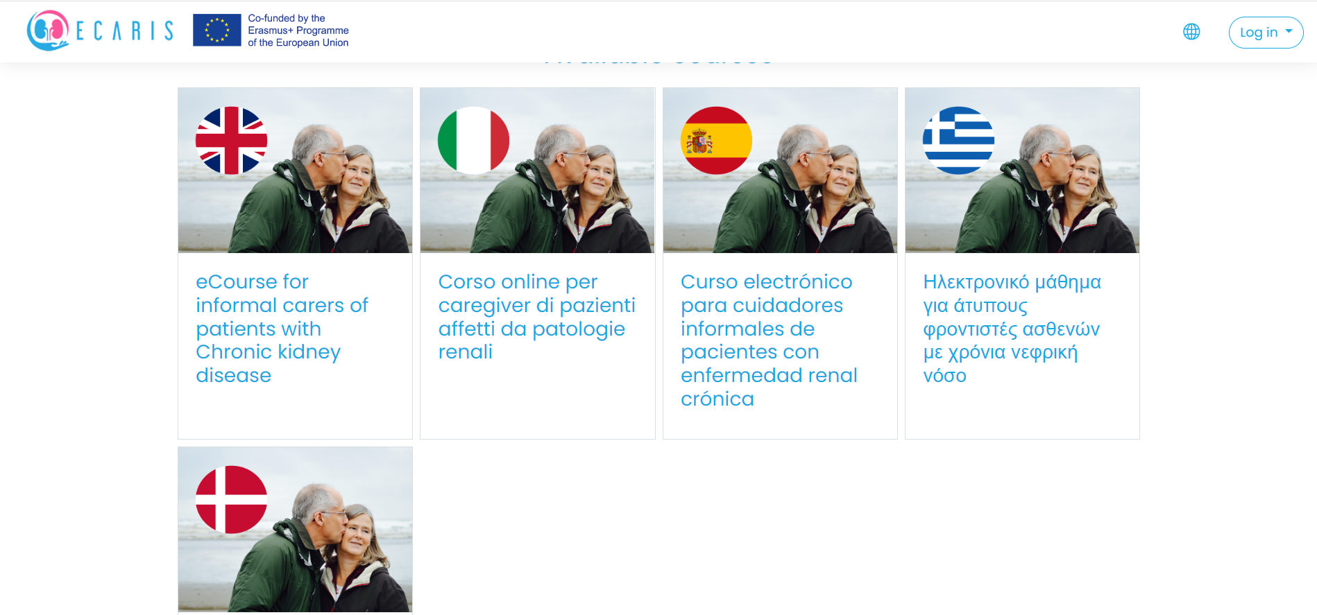
Figure 1: Homepege of Ecaaris eCourse

In order to make fruition intuitive and logical, the eCourse is organised in topics subdivided into specific modules, which are in turn composed of different sections, based on the topics to be covered. In addition to theoretical content, self-assessment tests, downloadable materials, multimedia resources are included in the training offer. The course currently available in English, Greek, Italian, Danish and Spanish and freely accessible upon registration at the link https://ecaristraining.eu/

The Ecaris partnership developed the following modules:
Information on Chronic Kidney Disease (CKD) and End Stage Renal Disease (ESRD)
The module is divided into 3 sections, whose goals are to:
- Recognize the symptoms of Kidney Failure
- Understand the progress of Kidney Disease
Understand the difference between Chronic Kidney Disease and Acute Kidney Disease
- Inform about the usefulness of eGFR test
- Inform about the existing types of RRT
- Present the applied method of each therapy that a patient with ESKD has to follow
- Explain in a simple way the surgical operations each therapy involves
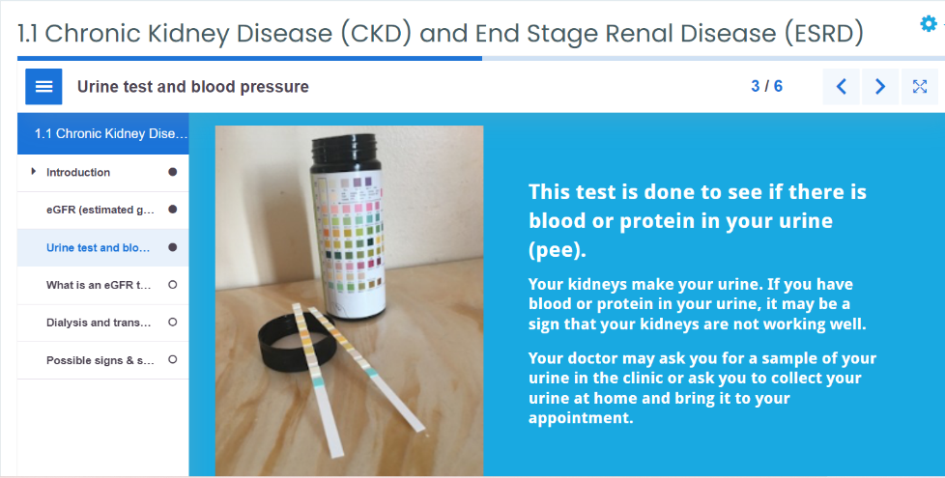
- Inform the learners about the existing types of RRT
- Present the applied method of each therapy that a patient with ESKD has to follow
- Explain in a simple way the surgical operations each therapy involves

Figure 2: Module 1 interface

By completing the module learners will acquire basic information about the stages and progression of Kidney Disease, the necessary knowledge to detect the basic differences between renal replacement therapies, the necessary information to detect and describe the basic differences between renal replacement therapies.

How to manage CKD and ESRD in daily activities
The second module is divided into 4 sections, whose goals are to:
- Provide information to adapt physical activity to people with CKD and ESRD
- Offer practical tools that help carers to adapt physical exercises to ESRD patients and in each stage of CKD
- Useful information to adapt physical activity to people with CKD and ESRD
- Practical tools that help careers to adapt physical exercises to ESRD patients and in each stage of CKD
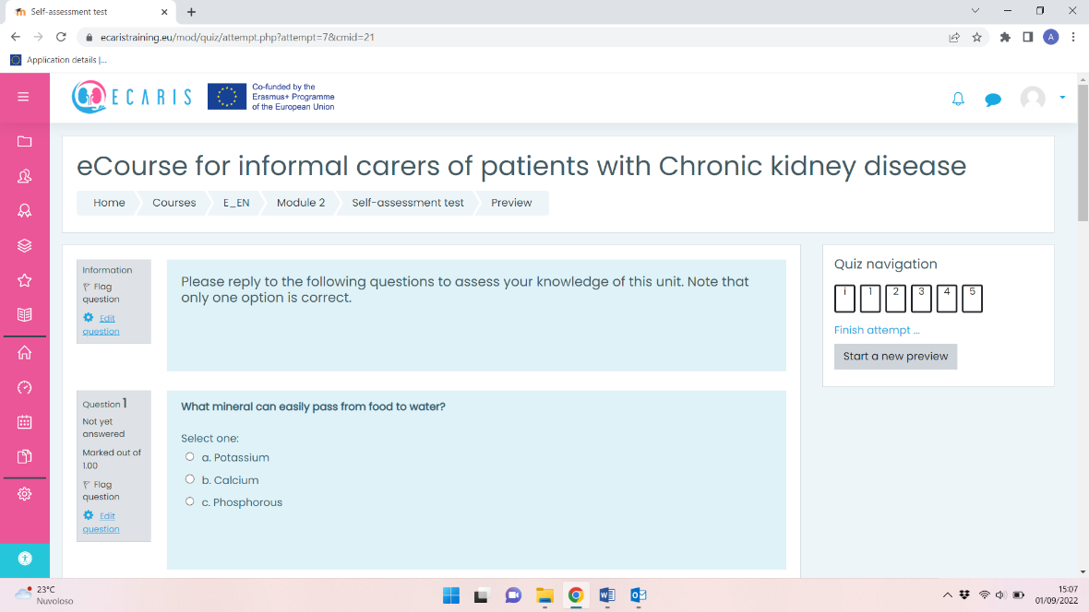
- Useful information on fistulas for people with CKD who are going to receive hemodialysis treatment.
- Practical tools for the CKD patient and her carer on fistula care.
- Acquire the necessary knowledge about some common problems in patients with kidney diseases.
Figure 3: Module 2 assessment test
At the end of the second module, learners will have obtained information and tools regarding how to adapt physical activity on CKD and ESRD patients, how to adapt the diet and fluid intake on the different stages of CKD, information about fistulas care, tools to prevent co-morbidity in patient with CKD.

Emotion, relations and communication
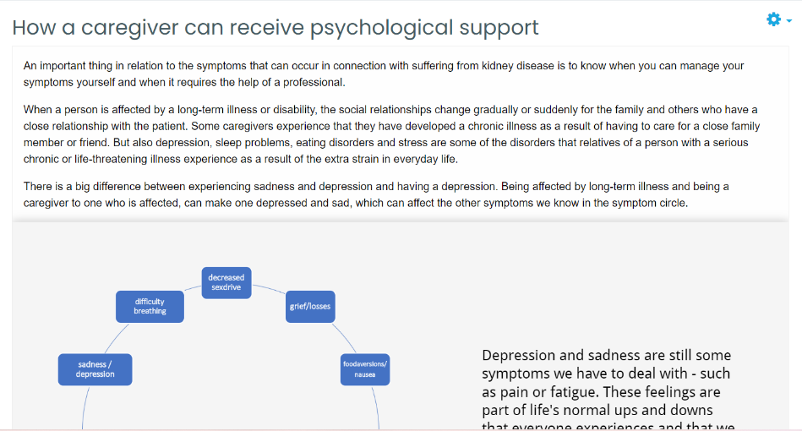
The third module is divided into 2 sections, whose goals are to:
- To gain the knowledge skills and confidence to be an active self-helper and improve communication skills
- To identify and address issues that impact upon everyday life beyond clinical outcomes
Figure 4: Module 3 interface
- To increase both patients and carer’s knowledge about positive thinking
- Know the risks of emotional disorders in the patient and in the carer
- Learn tips to prevent emotional disorders

At the end of the module, learners will have gained new knowledge and strategies regarding how to adapt their communication with patients and health professionals to avoid distress and emotional disorders.

Rights and opportunities for CKD patients and their carers
Aim of this module is to provide to learners:
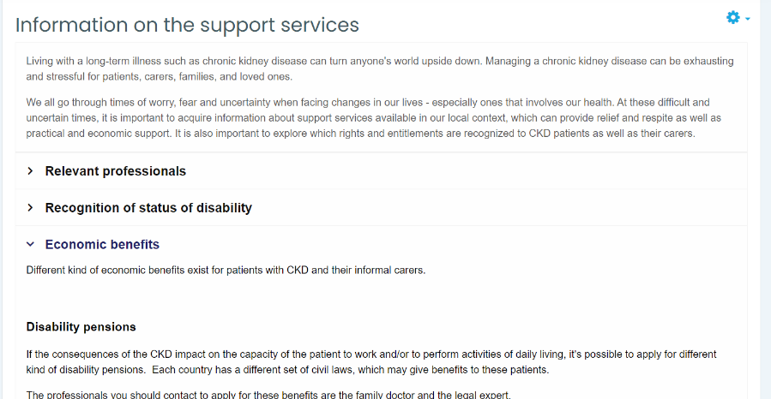
- Information on grants and support provided at national / regional level for CKD patients and their carers
- Useful services for carers of kidney patients and their loved ones (e.g. how to travel while a patient suffers from CKD or ESRD)
- Labor rights for kidney patients at national level

At the end of the module, learners will have obtained basic information on the support services available at national level to support CKD patients and their carers and on rights and entitlements recognized to them.

Pilot testing
The implementation of the piloting of Ecaris eCourse was aimed at checking if the proposed online training course and test the impact of participating in the educational programme in terms of increased well-being of the informal carers as well as of the patients. For this purpose, in each country at least 10 informal carers of people with kidney disease were involved. In total, 109 tester users (over the minimum goal of 40) were recruited in each country to test the MOOC course:
- 37 from Greece
- 22 from Italy
- 1 from Denmark
- 35 from Spain
- 14 users of the English platform

Participants Profile

The majority of the participants who completed the piloting were female, with this group accounting for a total of 63%. That means that more than 1/3 of the participants were women. An expected rate since the majority of kidney patients’ caregivers are women, please see Chart 1.0 below.

Chart 1.0

The largest percentage of participants were aged between 36-55 years of age, with this age group accounting more than 50% of the respondents. At the range of age 36 – 75 is the 81% of the participants, please see Chart 1.1 below.

Chart 1.1
The vast majority of respondents to the piloting lives in big cities (72%) and this is acceptable since hospitals and private clinics providing Renal Replacement Therapies (RRT) are located to capitals and big cities (cities with population more than 1 million citizens). The chart 1.2 presents the data.

Chart 1.2
The marital status of the participants presented to the chart 1.3. As you may see the majority is married at a rate of 74%. 12% is divorced and 14% remains single.

Chart 1.3

Over half of the respondents to the piloting had a high school diploma and 21% had a bachelor’s degree, chart 1.4 below:

Chart 1.4
On chart 1.5 you may identify a severe indicator. The majority of participants are out of the workforce (56%) and only 37% works full time.

Chart 1.5
The chart 1.6 imprints the health condition of the patients that receive support from their caregivers. As you can see the majority of patients undergoing dialysis and this is resulted due to the significant participation of caregivers that visited (with the patients) the dialysis unit in Aegina during summer period.

Chart 1.6

In our question to the respondents ‘’how many people you care for’’ (patients, family members) the answers we received are presented at chart 1.7. Thirty five percent reported that has to provide care to a patient and a family member as well. Two percent offers support to 5 people.

Chart 1.7
At chart 1.8 we can see that the majority of the participants providing care to 1 patient with CKD. Seven percent offers support services to 2 patients with CKD (this special category mostly refers to brothers/sisters with polycystic kidney disease, the only genetic hereditary disease of kidneys).

Chart 1.8

The vast majority of respondents has 2 or 3 years' experience in the field of career, with fourteen per cent of respondents to count 8 years of providing care, see chart 1.9 below. As we all know Kidney disease is a chronic condition that demands a multiyear support from the caregivers to patients.

Chart 1.9

Results
32 tester users have until now completed the eCourse and received the Certificates provided online by the system.

RATE OF SUCCESS (GRADES) | NUMBER OF PARTICIPANTS
0-40% | 0
40%-60% | 0
60%-70% | 4
70%-80% | 17
80%-90% | 9
90%-100% | 2

As can be noted from the table above the majority of the participants achieved a score more than 70%, in total 86% of the participants. This indicator captures the complete success of ECARIS e-learning course in transmitting information to caregivers and their patients. Information that add value for the learners and the content is useful and relevant with the caregiver’s inquiries-demands.
After the piloting they also completed a Feedback form (Annex 1), about their learning experience the majority of them evaluated the course highly comprehensible, in terms of language and content, and liked the structure in Modules. Specifically, when asked whether they believed that the training had the following added value, they provided the following results:
- 100% of respondents agreed that the training was helpful to improve their knowledge about Chronic Kidney Disease (CKD) and End Stage Renal Disease (ESRD)
- 100% of respondents agreed that the training was helpful to improve their knowledge how to medicate a patient with CKD or ESD
- 87,5% of respondents agreed that the training was helpful to improve their skills on how to manage CKD and ESRD in daily activities (diet, exercise)
- 72% of respondents agreed that the training was helpful to teach the different types of vascular accesses
- 78% of respondents agreed that the training was helpful to describe how to prevent co-morbidity in patient with CKD0
- 78% of respondents agreed that the training was helpful to highlight the importance of clear and positive communication with the patient and health
- 69% of respondents agreed that the training was helpful to resume all the support services which can help the carers and patients

When asked “What did you like the most about the e - learning course?” the participants answered:
“The information's simplicity”
“Learning through video”
“The organized presentation of information”
“That the whole process looks like a knowledge game”
“Despite being a transplant recipient, and believing that a lot is known about the disease and what it entails, it has helped me to continue learning and to put myself in the shoes of the carer.”
“A lot of interesting content to learn more about chronic kidney disease, care, details, etc.
“It is very well structured and very useful”

When asked “What did you dislike the most about the e - learning course?” only few participants answered. Their suggestions were:
“Maybe if the explanation would have been videos, it will be more entertained.”
“There are some language errors in the [Greek] platform that need to be corrected.”
“The many tags that are not really needed.”

Consistent with these suggestions, the platform was improved and more multimedia materials will be added regularly.
Finally, commenting their answers, most of the users reported that the course:
“Provides important information, especially for patients in stage 4 and preparing for stage 5 of CKD”
“It is a simple guide to help you learn at your own pace about kidney disease, how to cope with it, and how to help the patient.”
“I recommend it even to the patients themselves”
“It is easy to do, entertaining and you learn things without needing to know much about biology. Although there were some concepts that were difficult to understand.”
“Very well structured and it helps to understand what a chronic disease is.”

All the participants would suggest this online course to other carers.

Focus Groups in Madrid (SPAIN) and Aegina (GREECE)
During the ME in Madrid on 16/06/2022 was held in parallel a Focus Group with patients and caregivers (20 persons in total). The dialysis unit of Aegina organized five different Focus Groups of 8 -12 participants from July up to September 2022.
The purpose of these FG was to show the platform to patients with CKD and their caregivers, to record their first reactions, to help them exploring the piloting, to capture their comments, το generate hypotheses-ideas for future projects and of course to answer their likely questions.
We followed the convenience sampling method, as a non-probability sampling method, where the participants are selected for inclusion in the sample because they are available around a particular location under certain circumstances (patients with CKD and their caregivers).
We managed to have a free and open discussion among the attendees’ results in generation of new ideas that can be very useful for future decision-making about the content of the platform.
You can find below some of the questions and observations from caregivers and patients during the Focus Groups and the responses from the moderators.
Caregiver 1 (FG, SP): ‘’Sometimes I feel that I am burden for my beloved one (patient at stage 3 of CKD) by being overprotected’’.
Moderator: Stage 3 of kidney disease means that the kidney's function has been cut by half and most patients experience ancillary problems like high blood pressure or anaemia with symptoms as fatigue, weakness, pale or yellowish skin. It is common the lack of knowledge about CKD to force the caregiver to unnecessary reactions. ECARIS eCourse tries to provide information for the most important factors about handling CKD. Our recommendation: always improving the level of communication with the patient and the nephrologist.

Caregiver 2 (FG, GR) (with the patient undergoing dialysis): ‘’What should a patient on dialysis eat? What is forbidden?’’
Moderator: This is the 1 million dollar question. Dietary treatment is an important aspect of care for all patients with kidney disease. It is necessary to have a meeting with your nephrologist and your dietician to discuss individual needs for your diet regarding your unique, specific health condition.
Protein is needed for the repair and maintenance of body tissue and is a vital component of body fluids including blood. Some protein is lost from your body in the dialysis fluid. It is important to eat plenty of protein to replace what is lost so you do not become malnourished.
Potassium is the most difficult factor to handle for a dialysis patient’s mealing plan. Potassium is a mineral found in many foods, mainly fruits, vegetables and potatoes. It is necessary for muscle contractions but a very high level in the blood can be dangerous as it may cause irregular heart rythym. If your potassium levels increase, above normal, you will need to avoid certain foods that are high in potassium as advised by your dietician. High sources of potassium in the diet include bananas, dried fruit, peas, beans, spinach and potato products such as chips and crisps. Please keep in mind that high levels of potassium in blodd may cause a heart attack.

Caregiver (FG, GR): ‘’What are the symptoms of hyperkalaemia? How can I identify whether my husband has a high level of potassium?’’
Moderator: Hyperkalemia makes it hard for patient’s nerve and muscle cells to work like they should. As a result, the patient may have muscle weakness or muscle fatigue, tiredness, paralysis, abnormal heart rhythms, chest pain, or nausea.
Caregiver 4 (FG, GR): ‘’Is it possible for a dialysis patient to travel abroad?’’
Moderator: The module No 4 of our eLearning content provides all the necessary suggestions for someone on dialysis who wishes to travel. Please note that you should start your preparation with the booking procedure to the host dialysis centre 2 months at least before your scheduled departure. And a tip while you travel abroad: always keep with you (inside your wallet or on pdf format to your mobile phone) a copy of your EHIC card and the doctor’s instructions for your dialysis sessions’ parameters.

Caregiver 5 (FG, GR): ‘’Could a dialysis patient swim after his/her session?’’
Moderator: Two hours after ending his/her dialysis session and if there was no incident of continuous bleeding on the spots of puncture.

Caregiver 6 (FG, SP) (with the patient on CKD stage No 4): ‘’My wife reports that during her night sleep has uncomfortable feelings in his legs and sometimes feels pain’’.
Moderator: If it isn’t a nerve damage or medication complication your wife is likely to suffer from Restless leg syndrome that can be caused, or made worse by, anaemia (low blood count), iron deficiency (low iron stores in the body), or high calcium levels in the blood. These are all common in people with kidney disease. It is essential for your wife to keep a symptom diary to track the severity of your restless leg syndrome and to help identify any triggers. Your nephrologist will work with the patient so to try and find triggers for the restless leg syndrome which can then be avoided or adjusted.
Caregiver 7 (FG, GR): ‘’It would be really helpful for a caregiver exploring the e-learning course to find information about a recommended nutrition plan’’.
Moderator: We have conducted with the consortium of ECARIS project a weekly nutrition plan for patients at stage 1-4 of CKD, for patients undergoing dialysis and peritoneal dialysis or transplanted. However, the steering committee of our project that consists of nephrologists and nurses averted us from uploading this plan on the e-learning platform. Their strong argument is that a diet/nutrition plan should be patient centralized and a result of the discussion between the patient and his/her attending physician.

Caregiver 8 (FG, SP): ‘’Is it likely kidney stones lead to chronic kidney disease?’’
Moderator: A patient who has one kidney stone increases the risk of developing another one. This also increases the risk of chronic kidney disease and kidney failure. Chronic kidney disease is the gradual loss of kidney function over time. If it’s not treated properly, could progress until one or both of the kidneys stops functioning, called kidney failure. The best way to keep your kidneys healthy is by doing everything you can to prevent kidney stones from developing in the first place and monitoring your kidneys function with an ultrasound once a year. But no matter how many times we will repeat it on these focus groups, you must inform your attending physiscian about your general health condition.
Caregiver 9 (FG, GR) (dialysis patient and his caregiver): ‘’A dialysis patient with a central venous catheter can swim in sea during holiday?’’
Moderator: Swimming in sea is such a good exercise and a great way to spend quality time with family and friends. Fundamentally, swimming while on Dialysis is a decision that should only be made after consultation with your Healthcare Team. The nurse and nephrologist will also provide you the most effective catheter prophylactics (the scope is preventing an infection). In our dialysis unit in Aegina we suggest to our dialysis patients with permanent cental catheters only who wish to swim the product EXIT POCKET WP from EMODIAL.

Caregiver 10 (FG, GR): ‘‘How much water should drink per day a patient with CKD? Don’t you think that piece of information like this should be included in the platform? ’’
Moderator: This is 2nd most common question (after the question about the nutrition plan). And the answer remains the same: discuss this serious topic with your attending physician. Each patient is unique, individual. There is no rule or pattern for all the patients suffering from CKD to follow. For example, transplanted patients must drink at least 3 lt fluids/day. For peritoneal dialysis patients, there are no restrictions on fluids since they perform their dialysis sessions at home every day. But for dialysis patients that may urinate very little—or not at all any extra fluid must be removed by dialysis, and consuming too much fluid may cause buildup between dialysis sessions, resulting in the following: strong headaches, low blood pressure, and pericarditis. In our dialysis unit, we suggest our patients on dialysis consuming fluids up to 3% of their dry weight between their dialysis sessions. This is not acceptable scientific advice but it is a beginning for the patient to control the fluid consumption. For patients in stages 2 – 4 of CKD the nephrologist must define the daily fluid consumption since it depends on the patient’s general health condition.

Caregiver 11 (FG, GR): ‘‘Could a female patient with CKD be pregnant?’’
Moderator: Whether you think to born a baby, you should discuss it beforehand with your doctor or other healthcare provider. They know you, and they can help you make a decision that is based on your own personal health. There are many things to consider. You and your doctor should discuss them all very carefully. Some things that can affect a healthy pregnancy include:
-Your stage of kidney disease
-Your general health
-Your age
-Medication
-Having high blood pressure, diabetes, or heart disease
-Having other serious health conditions
-Protein in your urine

In most cases for women with moderate to severe kidney disease (stages 3-5), the risk of complications is much greater. For some women, the risk to mother and child is high enough that they should consider avoiding pregnancy.

Caregiver 12 (FG, SP): ‘’Is it possible to donate my kidney to my wife despite we have different blood groups?’’
Moderator: Kidney transplantation is the treatment of choice for patients with end-stage renal disease (ESRD) or at stage 4 of CKD (before starting dialysis – it is called a preemptive transplant). Blood group incompatibility remains a significant barrier to kidney transplantation. There are options for blood group incompatible donor-recipient pairs but each hospital’s transplant physician's team follows a different protocol. You should be advised by your attending physician, to perform all the necessary blood exams, and then decide on the best option for an ABO-Incompatible Living Donor Kidney Transplantation.

Caregiver 13 (FG, GR) (with the patient on CKD stage No 3): ‘‘What about the supplements vitamins? Should a CKD patient add them to his/her medication? ’’
Moderator: The vitamins are necessary for proper metabolism, protein building, and growth. They are very important for the health of a CKD patient. But herbal supplements may have ingredients that can raise potassium levels. The general rule is that people with CKD and people on dialysis should avoid herbal remedies and over the counter nutritional supplements. There may be unwanted interactions with prescribed medicines or other side effects. Always speak to your nephrologist before taking any herbal remedies, over-the-counter medicines, or nutritional supplements. If you are a transplanted patient, check with your transplant doctor and kidney dietitian whether any vitamin or herbal supplements are safe to take.

Caregiver 14 (FG, GR) (with the patient undergoing peritoneal dialysis): ‘’Is it possible for a peritoneal dialysis patient to have dialysis sessions as well?’’
Moderator: The situation you describe called a hybrid dialysis where the patient combines home peritoneal dialysis and in-center haemodialysis. Combination of once-weekly haemodialysis (HD) with peritoneal dialysis (PD) is a unique type of renal replacement therapy available in Japan and in Canada. This hybrid type of therapy (PD + HD therapy), patients usually undergo PD 5 days a week, HD once a week and no dialysis once a week, while it is a common clinical practice to perform PD 7 days a week for those on PD alone. Combination therapy intends to provide clearance and ultrafiltration which are insufficient with PD alone while maintaining a flexible lifestyle and better quality of life with PD. It was first approved by the national health insurance in 2010 in Japan and for Canada in 2014 , and dialysis facilities have been reimbursed for this treatment modality. In Greece this modality of therapies is not allowed yet due to bureaucratic issues.

Conclusions
The innovative methodology created through the project and its corresponding practical pilot for carers of kidney patients, converged into the conceptualisation and implementation of the Ecaris eCourse in order to reach the maximum number of direct and indirect beneficiaries of the project.
The course developed within the framework of the Ecaris project therefore reflects the entire course and results of the project that were elaborated by the partners in order to be easily accessible online. The testing phase of the eCourse, aimed at validating the developed and proposed online course, involved professionals from the sector and with the profile of the final users of the course.
Participants provided feedback after navigating the platform and reviewing the proposed content. All the participants gave a very positive assessment of the learning experience and based on their comments and recommendations the eCourse was finalised, by maximising the impact of the course and making it ready to be disseminated to the target group.
The Ecaris eCourse can therefore be considered to have achieved its objectives and it ensures that all those carers throughout Europe interested increasing their knowledge of kidney diseases affecting their loved ones, can do so in a self-taught way thanks to the e-learning.
Annex 1 – Platform Feedback Questionnaire

- What did you like the most about the e - learning course? Open answer
- What did you dislike the most about the e - learning course? Open answer
Read the following statements and indicate whether they are true or false for you:
- After completing the e - learning course I have improved my knowledge about Chronic Kidney Disease (CKD) and End Stage Renal Disease (ESRD)
- True
- False
- No answer
- After completing the e - learning course I have improved my knowledge how to medicate a patient with CKD or ESD
- True
- False
- No answer
- After completing the e - learning course I have improved my skills on how to manage CKD and ESRD in daily activities (diet, exercise)
- True
- False
- No answer
- After completing the e - learning course I have learned the different types of vascular accesses
- True
- False
- No answer
- After completing the e - learning course I have understood how to prevent co-morbidity in patient with CKD
- True
- False
- No answer
- After completing the e - learning course I have understood the importance of clear and positive communication with the patient and health professionals
- True
- False
- No answer
- After completing the e - learning course I have learnt information on the support services which can help me and my loved one
- True
- False
- No answer
- Would you recommend this e-learning course to other renal caregivers? Why yes or why not? Open answer

